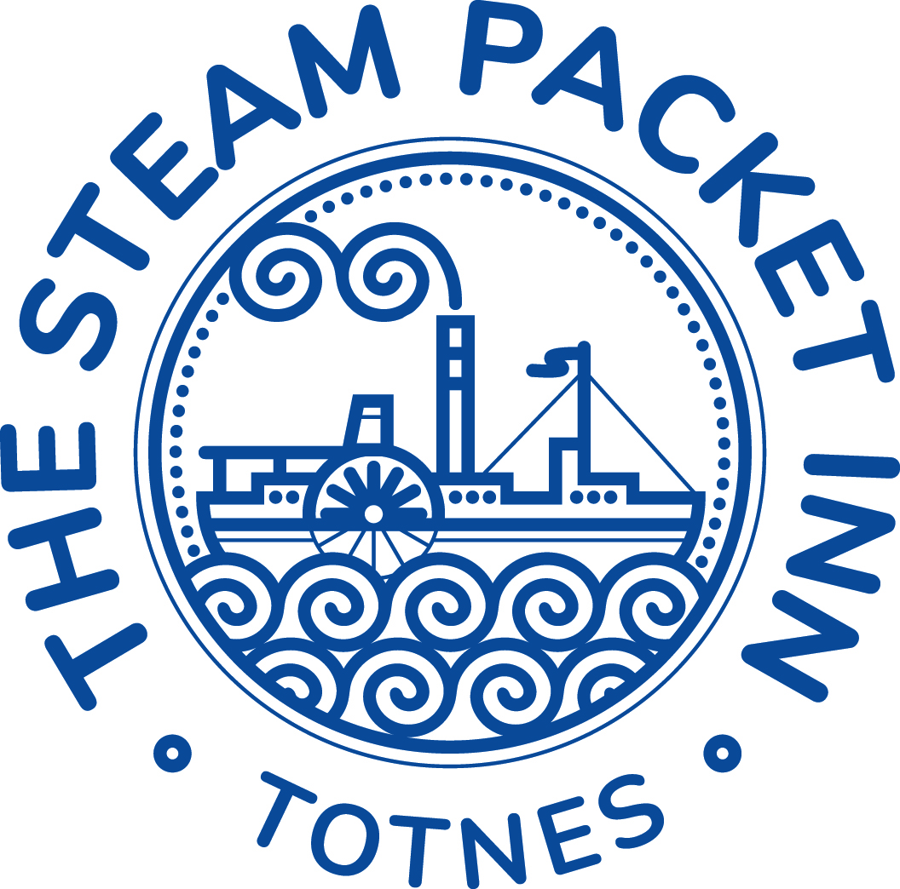

**Starters / light bites**

**Flatbread & mixed olives *£7 (V)*** *Hummus, sun-blushed tomato, balsamic & olive oil*

*(gf option available)* ***Add Italian cured meats +£3***

**Soup of the day £6 (V)**  Curried parsnip *soup served with white baguette (ve)*

**Creamy garlic button mushrooms £7.50**

*Crispy bacon, Toasted sourdough, rocket*

*(gf option available)*

**Devon crab on toast £9.50**

*Toasted sourdough, spring onions, watercress*

*(gf option available)*

**Smoked salmon & dill fishcakes £8.50**

*Poached free range egg, lemon & chive hollandaise sauce*

***Breaded whitebait £7.50***

*Lemon mayo, salad, local bread*

***Roasted aubergine, chickpea & tomato £7.50 (ve)***

*On sourdough toast, rocket, balsamic glaze*

*(gf option available)*

**Nachos £8 (V)**

*Salsa, jalapenos, mozzarella guacamole & sour cream* **Add chilli beef +£2**

**Mains**

**Brixham battered Cod fillet *£15*** *beer & dill batter, tartare sauce, chips, mushy peas*

**Whole tail breaded Scampi *£14*** *Tartare sauce, chips, salad*

**Monkfish & king prawn Thai green curry *£18.50*** *Thai vegetables, fragrant rice*

**Chicken, ham hock & leek pie £15** *puff pastry lid, fries, & peas*

**Local pork and leek sausages £14.50** *Creamy mash, red onion gravy*

**Halloumi penne pasta £17 (v)** *sun-blushed tomatoes, roasted red peppers & spinach in a rich tomato sauce, garlic bread*

**Beetroot & pepper falafel £16.50 (ve)** *sweet potato wedges, tomato, carrot & red onion salad, pitta bread, vegan coleslaw*

**Steak burger with *Monterey Jack cheese* £*14.50*** b*rioche bun, pickled red onion, gherkin, tomato & baby gem* fries & coleslaw

**Spicy bean burger with applewood vegan cheese £14 (ve)** *brioche bun, pickled red onion, gherkin, tomato & baby gem* fries & coleslaw

**28 day aged 8oz Sirloin steak £21** *chips, roasted vine tomatoes, flat mushrooms, peas, peppercorn sauce*

**Sandwiches *12:00 – 6pm***

Choice of granary or white bread – **(Gluten free bread available)**

Served with, salad & kettle crisp.

***Replace Kettle Crisps for chips £2 extra***

**Devon crab,** *lemon mayo & parsley* ***£10.50***

**Fish finger,** *Cos lettuce, tartare sauce* ***£8.50***

**BLT*,*** *mayo* ***£7.50***

**Prawn,** *mary rose sauce* **£9.00**

**Mature cheddar,** *real ale chutney* ***£7.50 (v)***

**Kids Meal £7all served with chips & beans or peas**

**Fish fingers**

**Battered chicken chunks**

**Pork sausages**

**Vegan sausages**

**Sides**

**Chips *£4* Cheesy chips *£5 Side salad £3.50***

**Garlic bread *£3.50* Cheesy garlic bread *£4.50***

**Desserts £6.00**

**Chocolate brownie**, chocolate sauce, vanilla ice cream

**Ginger sticky toffee pudding**, toffee sauce, clotted cream

**Lemon curd cheese cake,** *sweet pecan base*

**Vegan Belgian sweet waffle***, caramelised plums, maple syrup, vegan honeycomb ice cream*

**Local cheese board *£9.50***

*mix of local cheeses, ale chutney, grapes, crackers*

**Salcombe Dairy Ice cream (gf)**

**2 scoops £5.50**

**Vanilla**

**Honeycomb**

**Caramel**

**Strawberries and cream**

**Belgium chocolate**

**Peppermint chocolate mint**

All food is prepared fresh to order.

Nuts are used in our kitchen and dishes may contain nuts or nut oils.Fish dishes may contain bones.

Customers with food allergies are asked to discuss their dietary needs with our staff.