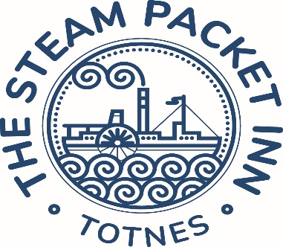

Customers with food allergies are asked to discuss their dietary needs with our staff prior to ordering

Breakfast is available to residents on a bed only package for a price of £15 per person

Sweet treats…

**Warm pancakes**

Fluffy pancakes served with berry compote & maple syrup

**£9.50**

**Greek yoghurt**

Served with berry compote, honey & granola

**£8.50**

**Warm Belgian waffles**

Sliced banana, chocolate sauce, Chantilly cream & toasted almonds

**£10**

Breakfast add-ons…

**-£1-**

Tomato – mushroom – baked beans – slice of toast

**-£1.50-**

Egg – hash brown – veggie sausage

**-£2-**

Sausage – back or streaky bacon

**-£3-**

Avocado – smoked salmon

Drinks…

Frobisher’s juices - **£3.50**

Voyager coffee – from **£3.20**

Pot of breakfast tea or Earl Grey - **£3**

Range of herbal teas - **£3.20**

Cooked breakfast…

**Full English Breakfast**

Smoked back bacon, butchers sausage, tomato, mushroom, black pudding, hash brown, baked beans, toast & eggs cooked to your liking

**£15**

**Vegetarian breakfast**

Vegetarian sausages, tomato, mushroom, hash brown, avocado, wilted spinach, baked beans, toast & eggs cooked to your liking

**£14**

**Eggs on toast**

Fried, poached or scrambled eggs on your choice of white or brown toast

**£9**

**Smashed avocado on toast**

Smashed avocado on toasted sourdough with poached eggs & chilli flakes

**£12**

**Breakfast sandwich**

Bacon, sausage or egg sandwich served on either white or brown bread

**£9**

**Ultimate breakfast sandwich**

Bacon, sausage, fried egg & hash browns served on Hallett’s bakery bread

**£12.50**